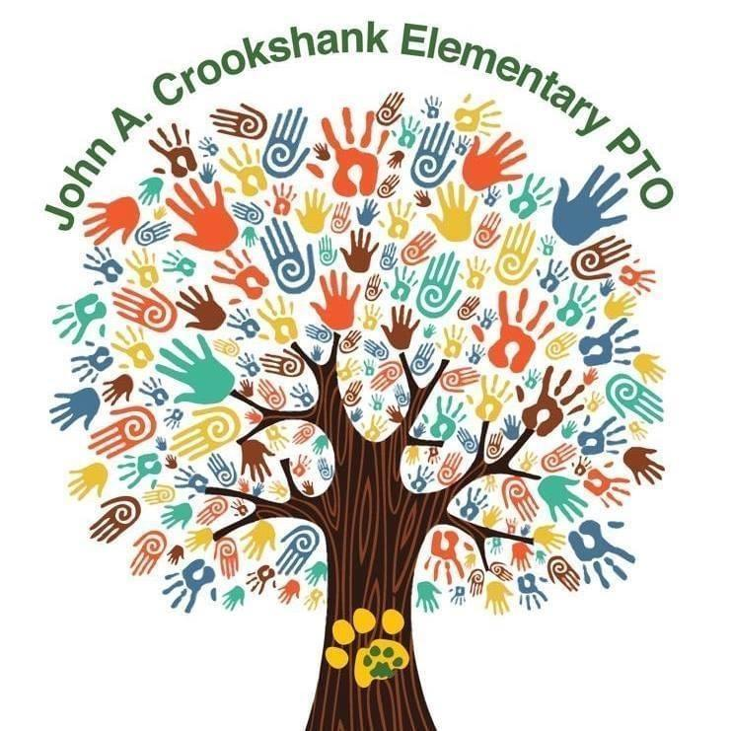
Dear Crookshank Families,
Here we are in November, a month that's all about thankfulness. Our students deserve the absolute best- that's why this month, we would like to add five business partners to our family. Business partners help our school get extra resources and experiences for our children- part of what makes being a Crookshank Cougar so special! We are spending this month focused on thanking our business partners and counting our blessings as we search for new ones!
As the Business Partner Liaison, I am asking for your help on this mission. Do you own a business? Could you or your employer help a school with a long list of needs, knowing that almost 750 children and 120 faculty and staff would benefit? Here are some of the areas where your contributions would be put to use:
Fun school events and resources including:
- Holiday and other celebrations to bring our families together
- Learning and positive behavior incentives to encourage our kiddos
- Teacher Appreciation events

Funding for other critical items, such as:
- Technology to enhance curriculum
- Providing classroom aids in the form of supplies or learning resources
- Field Studies and other programs that will impact our students
- Teacher/student supplies to restock classrooms when the supplies run out!

Several levels of sponsorship are available- all of which entitle your business to recognition and appreciation from us!

PRINCIPAL’S PARTNER $1,000:
- Sponsor name & logo promoted via school newsletters, social media, school and PTO websites, and electronic marquee
- Business banner displayed on CES fence for the school year (banner provided by business)
- Opportunity to distribute promotional material at school events
- Donated goods and services valued at this level will receive the same benefits

COUGAR PARTNER $500:
- Sponsor name & logo promoted via school newsletters, social media, school and PTO websites
- Business banner displayed on CES fence for the school year (banner provided by business)
- Opportunity to distribute promotional material at school events
- Donated goods and services valued at this level will receive the same benefits

CUB PARTNER $250:
- Sponsor name & logo promoted via school newsletters, social media, school and PTO websites
- Donated goods and services valued at this level will receive the same benefits
PAW PARTNER $100:
- Sponsor name & logo promoted via school newsletters, social media, and PTO website
- Donated goods and services valued at this level will receive the same benefits
If you are an individual or business owner interested in participating, or know of a business that might be interested, please contact me at franiheilman@yahoo.com or give me a call (904)484-4447. You can also sign up as a business partner and make a donation directly at http://crookshank-pto.cheddarup.com. All donations are tax deductible.
We have all faced unique challenges during the pandemic. No matter how many fundraisers we do this year, it will not be enough to provide everything that is needed. With your support, let’s meet this goal of five new business partners and achieve great things!!

Warmest Regards,

Frani Heilman
Business Partner Liaison

