

**THE COUGAR NEWS**

Vol. 5 3/02/2020

JOHN A. CROOKSHANK ELEMENTARY SCHOOL

**Principal’s Message**

Dear Cougar Families,

Please check out the Important Date section of this newsletter for some very important dates that are coming up for the month of January.

**Parents:** Please help us keep your child’s address and/or phone numbers up to date. If you have moved or change your number, please contact the front office or Ms. Cogar. This is very important so that we are able to reach you in a time of need.

**Reminder:** School starts at 8:25 a.m. Please make sure your child is in their classroom at 8:25 a.m. so that they are not missing instructional time. If your child arrives after this time, the parents must come into the front office and officially sign your child in and your child will receive a late pass to give to their teacher.

**PARENTS:** PLEASE DO NOT DROP OFF YOUR CHILD UNTIL 7:45 A.M. UNLESS THEY ARE IN EXTENDED DAY MORNING CARE OR A SAFETY PATROL ON DUTY.

We also wanted to remind parents that the cut off time for early check out is 2 p.m. every day except on Wednesday it is at 1 pm.

**During Dismissal** - We ask that all parents hang the parent pickup tag on your rear view mirror as this will expedite the parent pick up line. This is just a reminder of the new state law effective October 1, 2019 that prohibits drivers from holding their cell phone in their hands in a work or school zone.

**PARENTS:** When writing absence notes for your child’s, please put your child first and last name on the note. We have several students with same first and/or last names. We would like to make sure we are changing the correct student absences.

Sincerely

Marquez Jackson



**March 2-6, 2020**

Dr. Seuss Week

**March 2, 2020**

District Wide Registration Begins

for 2020/2021 School year

**March 4, 2020**

All Pro Dad Breakfast - 7:00 a.m. till 7:40 a.m.

Sebastian Middle School Meeting here for 5th graders –

Parents are welcome

Pre-K, VPK, Head Start Café @ 8:45 a.m. till 9:45 a.m.

**March 5, 2020**

Dr. Seuss Night 6:00 p.m. till 7:30 p.m.

**March 6, 2020**

1st Grade Field Study to Alligator Farm

**March 8, 2020**

Spring Forward – Move clock ahead 1 hour

**March 9, 2020**

PTO Meeting at 4 p.m. in the Media Center

Safety Patrol Field Study to St. Augustine Lighthouse, Chili and Barnes and Nobles

PTO Spirit Night – Chick Fil A 5:30 p.m. till 7:30 p.m.

**March 10, 2020**

2nd Grade Field Study to Jacksonville Zoo

**March 12, 2020**

Field Day

Third Quarter Ends

**March 13, 2020**

Teacher Planning Day / NO SCHOOL

**March 16-20, 2020**

Spring Break / No School

**March 23, 2020**

Classes Resume

**March 27, 2020**

PTO Dance

**March 31, 2020**

Third Quarter Report Cards Issued

**Crookshank Pre-K**

**(ESE, VPK, Head Start)**

**Parents Café**

**Wednesday, March 4, 2020**

**8:45am to 9:45am**

Come enjoy time with other Pre-K Parents!!! We will be doing fun History and Geography tasks to do at home with your children.



Please bring your ID and sign in at the Main Office.



*[Grab your reader’s attention with a great quote from the document or use this space to emphasize a key point. To place this text box anywhere on the page, just drag it.]*

**3/8/2020**



# District-Wide Registration

**New Students**  
District-wide registration for the 2020-2021 school year will begin on March 2, 2020. Starting on that date, you will be able to click the “Register My Child For School” button on the District website or one of our school websites to complete an online registration form for your child.

**Returning Students**  
Beginning the week of March 23, parents/guardians of all current students will receive an email from PowerSchool to complete the annual Returning Student Verification Form for the upcoming school year. The email will be sent to the parent/guardian listed as the first contact and will contain the link and instructions needed to complete the verification. All parents/guardians must complete the Returning Student Verification Form even if your child will not be returning to SJCSD in August.

Guardian of all current 5th and 8th grade students who are going to 6th and 9th grade must provide or upload new address documentations in order for your child to be fully register for Middle/High School next year. Your child **WILL NOT** receive their schedule unless this is provided.

If you have children in multiple schools, you will receive a snapcode (a link) for each child. Snapcodes may be sent on different days depending on the school each child attends.

Crookshank Elementary School has 16 slots available for VPK for the 2020-2021 School year. You are now be able to do the online registration for this. Parents/Guardian must provide all the necessary documentations including the VPK Eligibility letter from Episcopal Children’s Services. Please call Ms. Cogar at 1-904-547-7846 to reserve your child a spot.

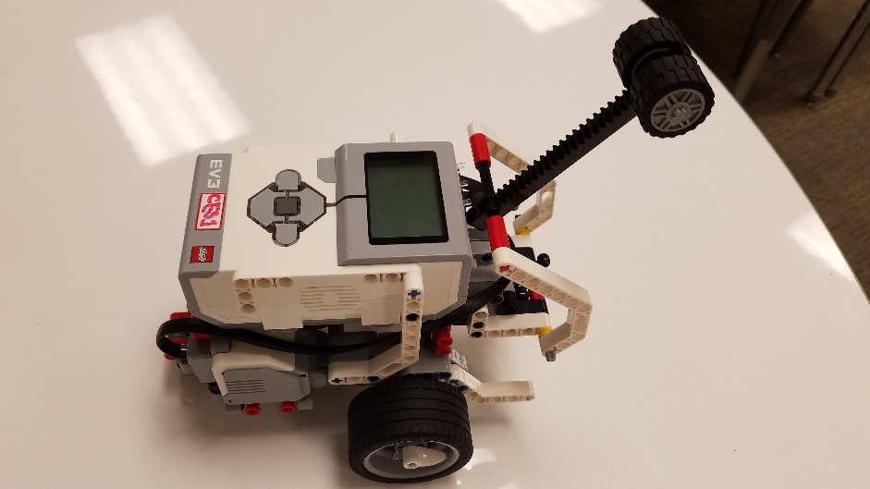

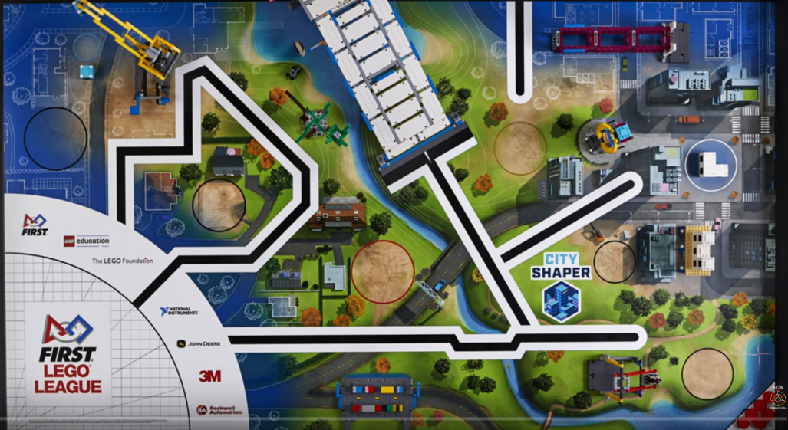Did you know we had a robotics team? Our robotics team meets on Mondays and Fridays to work on programming the robot we designed to solve missions. We have to work as a team, collaborate, and be inclusive of everyone’s ideas. More importantly, we have fun, especially when one of our programs are successful and we complete a mission.

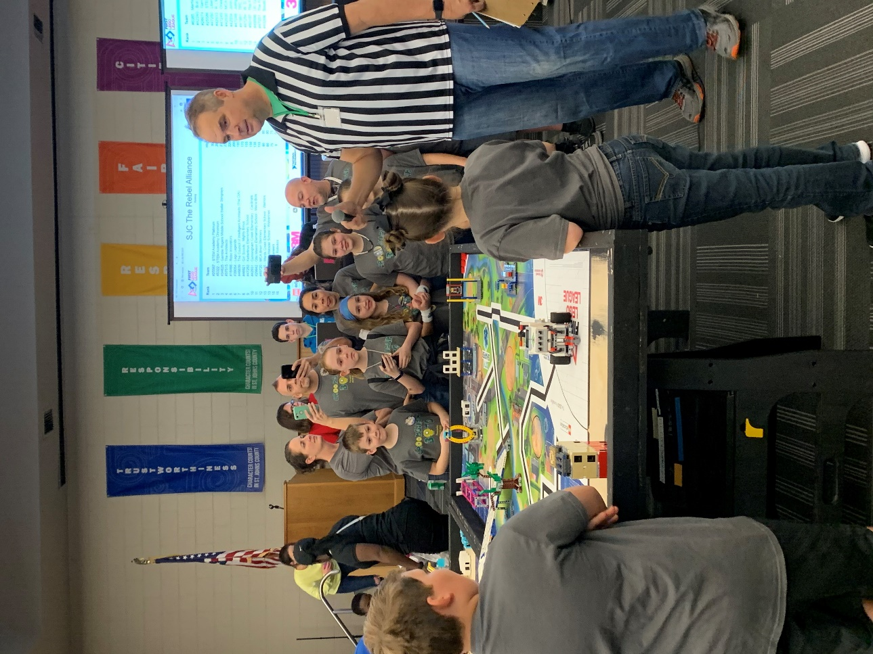On Saturday, January 25th, the Crookshank Bots competed at FCTC against 15 other teams. Our highest robotics game score was 185. This was no easy feat though. We had to adapt one of our missions **last minute** after we were told it was a “**GO**.” Molli and Mikey did an Amazing Job **staying cool under all the pressure** of lining up the robot correctly and successfully completing all the missions in 2.5 minutes. We also had to speak in front of 3 sets of judges to share our robot, our innovation project, and how our team 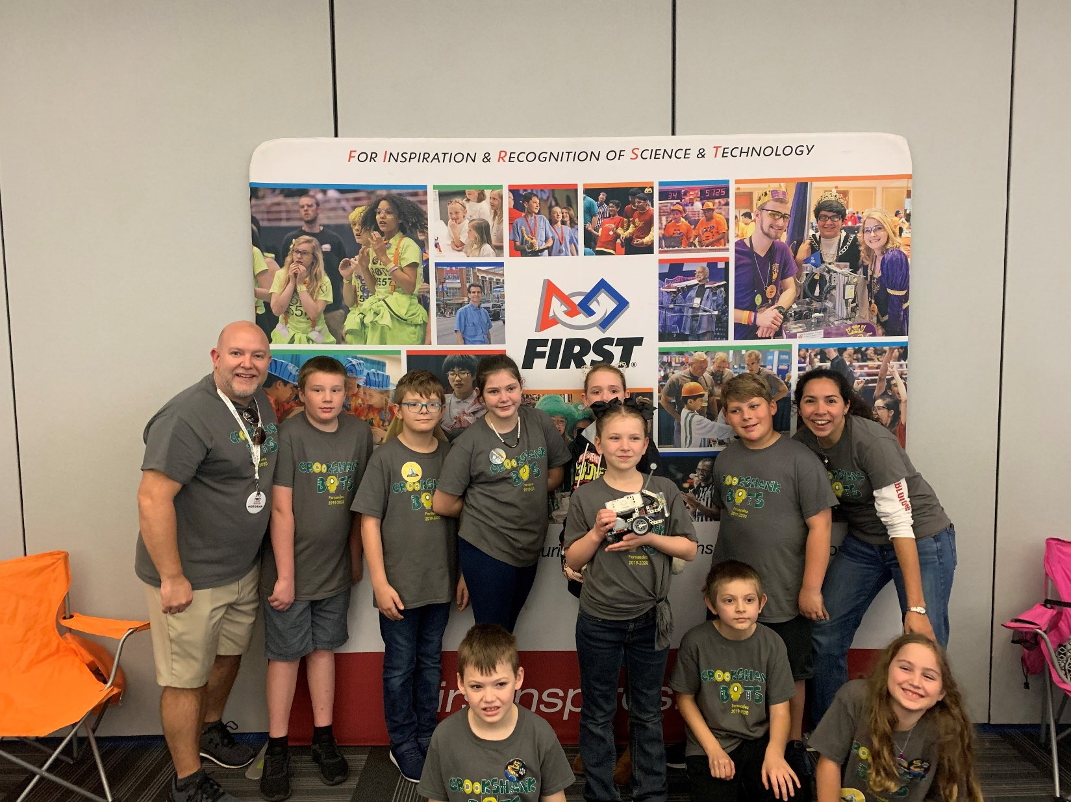works together and uses First Lego League’s core values.

Be on the lookout for Crookshank Bots walking through the hallway.

****Miss Fernandez is on the lookout for more Crookshank Bots for next year’s competition****

Parents:

This afternoon the District Office put three (3) school year calendars on the district’s website for public input. Please view this information. Public input is or was through February 27, 2020.

The link is [https://www.stjohns.k12.fl.us/calendar/proposed/](https://nam05.safelinks.protection.outlook.com/?url=https%3A%2F%2Fwww.stjohns.k12.fl.us%2Fcalendar%2Fproposed%2F&data=02%7C01%7CLisa.Cogar%40stjohns.k12.fl.us%7C3ecd3e1c154b4414a39008d7b72e7007%7Cb3b3d057fc124f3f92f472be6e844351%7C0%7C0%7C637179282388111230&sdata=XD%2B3eUCeZLis0DM8eCV2gAH8ZXVjjYRa7Nc%2Bh6F0tBs%3D&reserved=0)

**Come to Dr. Seuss’ Family Reading Night!!!**

**All students in Grades PreK-5 with an adult!**

Thursday, March 5, 6:00-7:30 PM



**Bingo for Books!! Scavenger Hunts!! Puppetry Shows!!**

**Reader’s theater - see your teachers on stage!! Pictures with Cat in the Hat!! Read Aloud!! Coloring and Crafts!! Face Painting!! Videos!!**

*Cotton Candy Truffula Treats for All Children!*

|  |  |  |  |  |  |  |  |  |  |
| --- | --- | --- | --- | --- | --- | --- | --- | --- | --- |
| |  |  |  |  |  |  |  |  |  | | --- | --- | --- | --- | --- | --- | --- | --- | --- | | |  |  |  | | --- | --- | --- | | |  |  | | --- | --- | | [DonorsChoose](https://nam05.safelinks.protection.outlook.com/?url=https%3A%2F%2Femail.donorschoose.org%2Fls%2Fclick%3Fupn%3DA0ZTvq2iPwfwXmxvtnT5eoQuL5tei0dWSFUcOTbbj-2Fpz9Z5Re8u38T8WrjSIf-2F-2Fetrk7_XKguIg0rm3l2miqlagO-2FzmP1TFwQIRNCQX6uNlCuLpBYBfRZ2tqhqUoq2x5P-2B513-2B27oiw6WQl3wZKvzIxIsV8s2XG1B-2F22PHRLPIieP0vWV10APv8Yq0YNdKIRH-2FjI2Uq5ojHgbUi0Y32tu4tVH9LlMh9U67XJl7dD-2Bm6-2FL40nHfY-2F-2BbH6bhu-2BuTLgVjduC-2F3nAfBvpZEfLDetTmrqfUb0HpXbkX6zHKhdztUPVtPBOJhFFM-2FFTBZ6kaJA-2BNjJ8LJAO9HPvy1PB5Jy0QzvvgdJF4-2FY06bpdeSnh7slfwUwho5jO4Kjv2ZSME3-2BoN-2FVuujtxdCuZQMYY6YA1WldFmyNSvORHtFthPfhOz8Gi7tnB-2FxUFnbpc5br-2BMvixd1RS5eYR8IyoyYAy-2FCjewjTai51eMJPZsuqIdzgtHgQnQfUt59Bk4cDMO7133luDoYbngjrCJzDYZUADHx0l9TXncA-3D-3D&data=02%7C01%7CLisa.Cogar%40stjohns.k12.fl.us%7Cb7e48fee6fa9412f3fd108d7b730f34c%7Cb3b3d057fc124f3f92f472be6e844351%7C0%7C0%7C637179293183549910&sdata=odj%2BGU%2F38pFD9RTdfN4TS9A3FMsQrpuKeVHroNLbUj8%3D&reserved=0) |  | | | |  |  |  |  | | --- | --- | --- | --- | | Hi Shannon, Ms. Simpson's classroom project is halfway to its funding goal, hooray!  Hi Parents:   A teacher at John A Crookshank Elementary School, Ms. Simpson, has a project that just got halfway to its funding goal. Looks like folks are excited about this one!  Let’s give these students at John A Crookshank Elementary School something tangible to celebrate today. With a little more help, the students in Ms. Simpson’s class will receive the materials they need for this awesome project:   |  |  |  | | --- | --- | --- | | |  |  | | --- | --- | |  | **Ms. Simpson**  John A Crookshank Elementary School  Nearly all students from low‑income households  St Augustine, FL |  Coding in the Art Room Help me give my students the tools for exciting STEAM-based projects in the Art Room!  My students are always excited to get creative, using new tools in the Art Room! They enjoy hands-on projects where they can explore and experiment while creating their masterpieces.  Help me encourage their creativity and curiosity by adding some fun technology-based learning tools to our classroom!  I teach Art to students in Grades Pre-K through 5th. Our school has a large percentage of low income families, which can make it difficult for some students to have access to various types of technology at home. I'd love to have the opportunity to introduce them to these things in my classroom!  I am a huge believer in integrating technology in the Art Room when possible and would love to see my students grow academically through the use of these fun coding tools.  My goal is for every student in my school to find a little bit of joy in the Art Room. Whether it is through painting, drawing, sculpting, or creating art through coding! My Project My students and I would be thrilled to have the opportunity to use technology in the Art Room on a regular basis. My goal is to add a set of Artie 3000 coding robots to our classroom, along with the tablets required to control and code.  Teaching students to create art through coding enhances their creativity and increases their critical thinking skills.  Students will work in groups as they communicate and collaborate, helping them to build teamwork skills along the way.  "Art has the role in education of helping children become like themselves instead of more like everyone else." - Sydney Gurewitz Clemens  [**Give to Ms. Simpson**](https://nam05.safelinks.protection.outlook.com/?url=https%3A%2F%2Femail.donorschoose.org%2Fls%2Fclick%3Fupn%3DRuDNheVVaoQCMFEIwZgdP0e3q1P-2BPW0Ir1gXVqWezV5ewe1KD4-2FvVjNypBVjbZ7IpT9-2FBwK4iO1VhZlSCEQ3rSUTV2obPkd4CfOK5gbttaiqTiQOwZQ-2B6WBhPbiqmSUPipePYIoMxp8Ex0xzgEGmXNsiCQvxRtef0oe-2Fr2SDwF1CgVmXSozDD3ZcVBMJSwthwUiz-2B4bldLld2b0edmDHjr2yEHvasC7O5ASqMPjUPsJsrfkPnS-2FmGuc5CXKy70jHFDG1eZKZ-2F5ugHmqSFYcmj-2F2QoQeaRPIrTSuUrS8JHmhri4TeiwKLmexObTxiQd4fg545_XKguIg0rm3l2miqlagO-2FzmP1TFwQIRNCQX6uNlCuLpBYBfRZ2tqhqUoq2x5P-2B513-2B27oiw6WQl3wZKvzIxIsV8s2XG1B-2F22PHRLPIieP0vWV10APv8Yq0YNdKIRH-2FjI2Uq5ojHgbUi0Y32tu4tVH9LlMh9U67XJl7dD-2Bm6-2FL40nHfY-2F-2BbH6bhu-2BuTLgVjduC-2F3nAfBvpZEfLDetTmrqfUb0HpXbkX6zHKhdztUPVtPBOJhFFM-2FFTBZ6kaJA-2BNjJ8LJAO9HPvy1PB5Jy0QzvvgdJF4-2FY06bpdeSnh7slfwUwho5jO4Kjv2ZSME3-2BoN-2FVu-2FzpDUt05D0F8AcPYezqT5pYwQNuV0N5XD6cyIXhEOkuesqeQ8blzzTe6UJ5lmLQ6uWG1fVMf5zMVto2A4hxt19ww3AY8aw0s2TevLATc0kJn-2Bh5KQdaoHodyPx3eW-2FMcwGcvgwkPyK2CcrCC9L9bHQ-3D-3D&data=02%7C01%7CLisa.Cogar%40stjohns.k12.fl.us%7Cb7e48fee6fa9412f3fd108d7b730f34c%7Cb3b3d057fc124f3f92f472be6e844351%7C0%7C0%7C637179293183599882&sdata=2OGJ0o94GukXo0pLZ6LkewNM4vIW%2BaUpFtZlzzDFmRo%3D&reserved=0)  **Give to Ms. Simpson** | | | | |

***SAVE THE DATE***

JOHN A. CROOKSHANK ELEMENTARY SCHOOL

60TH ANNIVERSARY

COMING SOON

SATURDAY, APRIL 18, 2020

TIME TO BE ANNOUNCED



***JOHN A. CROOKSHANK ELEMENTARY***

*It’s time to order your yearbook!*

***Order now and save!***

*iEs el momento de ordenar su Anuario! iOrden ahora!*

***ORDER ONLINE***

[*www.leonards.com/yearbooks*](http://www.leonards.com/yearbooks)

*Haga su pedido con tarjeta de credito a la* [*www.leonards.com/yearbooks*](http://www.leonards.com/yearbooks)

*Access code:* ***C482411***

*\*\*\*\*\*\*\*\*\*\*\*\*\*\*\*\*\*\*\*\*\*\*\*\*\*\*\*\*\*\*\*\*\*\*\*\*\*\*\*\*\*\*\*\*\*\*\*\*\*\*\*\*\*\*\*\*\*\*\*\*\*\*\*\*\*\*\*\*\*\*\**

***Price: $13.00***

*\*\*\*\*\*\*\*\*\*\*\*\*\*\*\*\*\*\*\*\*\*\*\*\*\*\*\*\*\*\*\*\*\*\*\*\*\*\*\*\*\*\*\*\*\*\*\*\*\*\*\*\*\*\*\*\*\*\*\*\*\*\*\*\*\*\*\*\*\**

*To pay by cash, check or money order, complete the order form envelope that was sent home with your child and return to your school*

*Para pagar en efectivo, cheque o grio postal, complete el sobre del formulario de pedido que fue enviado a casa con su hijo y regreses a su escuela.*

*Make checks or money orders payable to: LEONARD’S*

*Hacer cheque o giro postal a nombre de: LEONARD’S*

*Price includes sales tax. Exact amount * No change given*

*Los taxes estan incluidos en los precios. Cantidad exacta * No sera dado cambio*