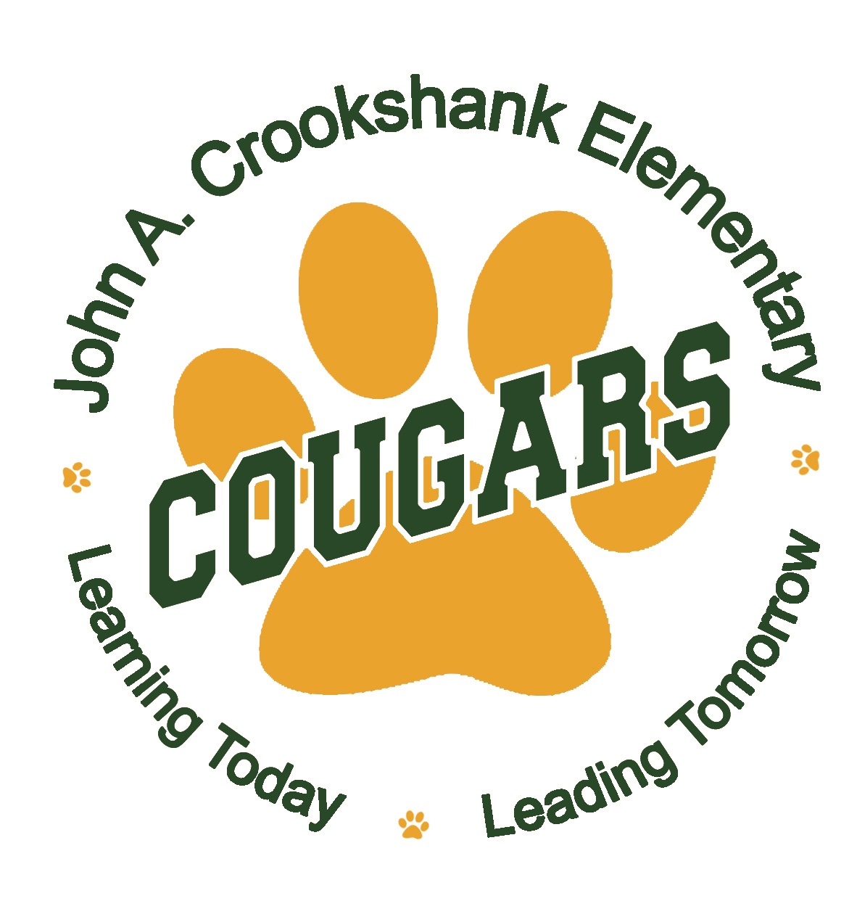
April
2022
John A. Crookshank Elementary State Testing Calendar
Sunday | Monday | Tuesday |  | Wednesday |  |  | Thursday |  | Friday |  | Saturday
3 | 4 | 5 |  | 6 |  |  | 7 |  | 8 |  |  | 9
 |  |  | Grade 4, 5  FSA Writing |  |  |  |  | Grade 3  FSA Reading  Session 1 |  | Grade 3  FSA Reading  Session 2
10 | 11 | 12 |  | 13 |  |  | 14 |  | 15 |  |  | 16
 | Makeups | Makeups |  | Makeups |  |  | Makeups |  | Holiday
May
2022

Sunday | Monday | Tuesday |  | Wednesday |  |  | Thursday |  | Friday |  | Saturday
1 | 2 | 3 |  | 4 |  |  | 5 |  | 6 |  |  | 7
 | Grade 4, 5  FSA Reading Session 1 | Grade 4, 5  FSA Reading Session 2 |  |  | Makeups |  | Makeups |  | Makeups
8 | 9 | 10 |  | 11 |  |  | 12 |  | 13 |  |  | 14
 | Grade 3, 4, 5  FSA Math  Session 1 | Grade 3, 4, 5  FSA Math  Session 2 |  | Makeups |  |  | Makeups |  | Makeups  (last day for reading and math)
15 | 16 | 17 |  | 18 |  |  | 19 |  | 20 |  |  | 21
 | Grade 5  Science  Session 1 | Grade 5  Science  Session 2 |  | Makeups |  |  | Makeups |  | Makeups  (last day for Science)

