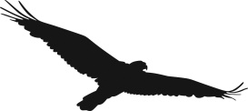
June 14, June 21, June 28, July 5, July 12, June 14, June 21, June 28, July 5, July 12

Summer Soar!!!!!!!!!!!!!!
Free Lunch at Crookshank! And Free Books!
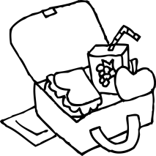
Every Thursday, June 14-28, July 5-12, 11:30-12:00
Read-Alouds!
Pick a free book!
Add to your Summer Reading Olympics Log!!!

June 14, June 21, June 28, July 5, July 12, June 14, June 21, June 28, July 5, July 12

June 14, June 21, June 28, July 5, July 12, June 14, June 21, June 28, July 5, July 12

Summer Soar!!!!!!!!!!!!!!
Free Lunch at Crookshank! And Free Books!
Every Thursday, June 14-28, July 5-12, 11:30-12:00
Read-Alouds!
Pick a free book!
Add to your Summer Reading Olympics Log!!!

June 14, June 21, June 28, July 5, July 12, June 14, June 21, June 28, July 5, July 12

