John A. Crookshank Elementary
1455 N. Whitney Street
Saint Augustine, FL 32084
(904) 547-7840

Mr. Marquez D. Jackson Mrs. Yvette Cubero-Gonzalez Mrs. Angela Rodgers
Principal Assistant Principal Assistant Principal
Marquez.Jackson@stjohns.k12.fl.us Yvette.Cubero-Gonzalez@stjohns.k12.fl.us Angela.Rodgers@stjohns.k12.fl.us

Tuesday, October 24, 2017
Dear Parents,
Literacy is such an important part of your child’s education, and we enjoy inspiring a child’s love of reading. Students are invited to wear a storybook themed Halloween costume and/or attire on Tuesday, October 31st to school (no weapons, wands, or masks). Our school would like to continue to promote the love of reading therefore, we would prefer for costumes to be connected to a character(s) in a book.

Some other things to consider:
- Costumes should not include masks, props, or heavy face makeup.
- Costumes should follow school dress code: No spaghetti straps, no midriff tops, and appropriate shoes.
- Students will need to be able to use the bathroom, or if needed change independently in their costumes.
- Students will still be following their usual schedules, which may include recess so they may want to wear an alternate costume to avoid getting their new one dirty.
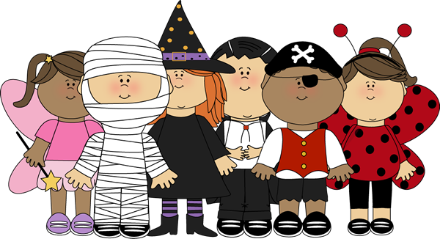
Thank you for your cooperation and support with this fun day. We can’t wait to see all the students all dressed up! Have a safe and happy Halloween!

