[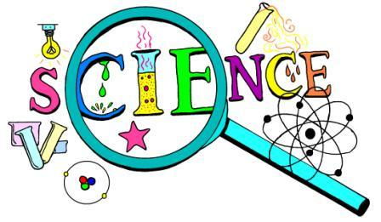](http://www.stjohns.k12.fl.us/media/wp-content/uploads/sites/127/2017/11/science.jpg)

On January 9, 2018, the St. Johns County School District School Board conducted a public hearing to receive comment from the community related to the final list of recommendations for science instructional resources for this year’s adoption. Committees composed of teachers, district content experts, parents and community members compiled the lists. Please visit <http://www.stjohns.k12.fl.us/media/about/textbooks/adoption/> to view the final recommendation selections.

Board action on the final adoption of science instructional materials is scheduled to take place at the School Board meeting on February 13, 2018.  If you would like access to available printed materials or require assistance reviewing the online resources, please call the Instructional Resources and Media Services office at 904.547.3947. Materials are available for review from 8:00 AM – 4:30 PM when district offices are open.