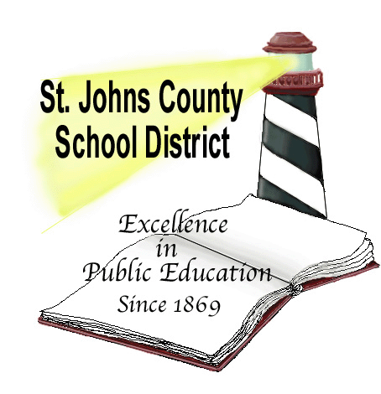 Student/Athletic Accident Insurance

July 1, 2016- June 30, 2017

The St. Johns County School Board has purchased accident coverage through BMI Benefits, to protect all students involved in any school sponsored and supervised activity including Sports against accidental injury or death occurring while the policy is in force. However, please note that if your child is currently covered under any other medical policy, claims MUST be submitted under that policy FIRST.

The Student Accident Insurance policy has caps on medical benefits and a $100.00 deductible.

Claims Instructions:

In the event of accident, notify the school immediately

Secure a claim form from the school

Complete and Sign the claim form
- Claim MUST be filed within 90 days of the accident or the claim could be Denied

Include: Itemized bills and the Explanation of Benefits from your primary Insurance Carrier.

OPTIONAL

VOLUNTARY - Student Accident Benefits

Provides coverage for accidental injuries occurring around-the-clock, at home, at school, on weekends and during the summer. Coverage is effective from the date the application and premium are received by the Company, until one year after the school year began.

For additional questions or information, phone or e-mail

K&K Insurance Group
855-742-3135
www.StudentInsurance-kk.com

*Applications online*

